**M.Sc C.S - I**

**SEM I**

**E-Journal**

|  |  |
| --- | --- |
| **Roll No.** | 027 |
| **Name** | OJHA ABHISHEK DEVMANI |
| **Subject** | ARTIFICIAL INTELLIGENCE AND PROGRAMMING ROBOT |

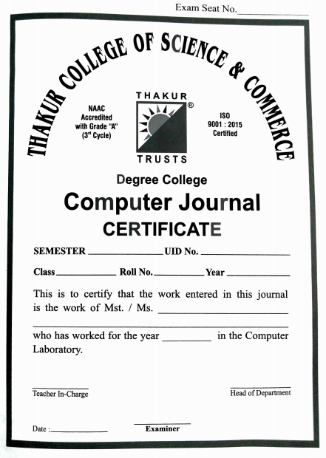

**22-12-2021**

**Ashish Trivedi**

**Meghna Singh**

**2021-2022**

**Ojha Abhishek Devmani**

**2021-2022**

**027**

**MSc-CS**

**Sem - I**



CERTIFICATE

This is here to certify that Mr. **OJHA ABHISHEK DEVMANI**, Seat Number **027** of M.Sc. I Computer Science, has satisfactorily completed the required number of experiments prescribed by the UNIVERSITY OF MUMBAI during the academic year 2021 – 2022.

Date: **22/12/2021**

Place: **Mumbai**

Teacher In-Charge Head of Department

**Meghna Singh** **Ashish Trivedi**

External Examiner

**INDEX**

|  |  |  |
| --- | --- | --- |
| **Sr. No.** | **Practical Name** | **Date** |
| **1** | Write a program to implement (BFS) algorithm for a given standard problem. | 06-09-2021 |
| **2** | Write a program to create a robot  **(i)** With gear  **(ii)** Without gear and move it forward, left, right | 20-09-2021 |
| **3** | Write a program to create a robot and add two motors to it, make it move forward, left and right. | 11-10-2021 |
| **4** | **4.A** Write a program to create a robot that moves in a square using a while loop.  **4.B** Write a program to create a robot that moves in a square using a for loop. | 16-10-2021 |
| **5** | Write  a program to create a robot with light sensors to follow a line. | 15-11-2021 |
| **6** | Write  a program to create a robot that does a circle using 2 motors. | 22-11-2021 |
| **7** | Write a program to create a path following robot. | 29-11-2021 |